EXPERIMENT 7
Execute and display the results for the following commands in Kali Linux Operating Systems:
cd command
cp command
ls command
AIM : To execute and display the results of the cd, cp, and ls commands in the Kali Linux Operating System.
DESCRIPTIONS
1. cd Command
The cd command stands for Change Directory. It is used to move from one directory to another in the Linux file system.
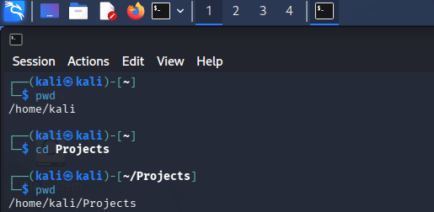
2. cp Command
The cp command stands for Copy. It is used to copy files or directories from one location to another.
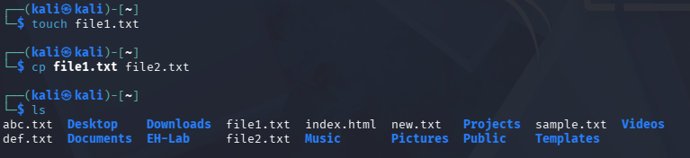
3. ls Command
The ls command stands for List. It is used to display the files and directories present in the current working directory.

RESULT : The cd, cp, and ls commands were successfully executed in Kali Linux. The cd command was used to change the current directory, the cp command was used to copy a file, and the ls command was used to display the files and directories in the current working directory.

